**NAME- Kanishka Kukreja**

**ROLL NO. – 16093**

**COURSE- Bsc(H) CS**

**PROGRAM-1**

**CODE:**

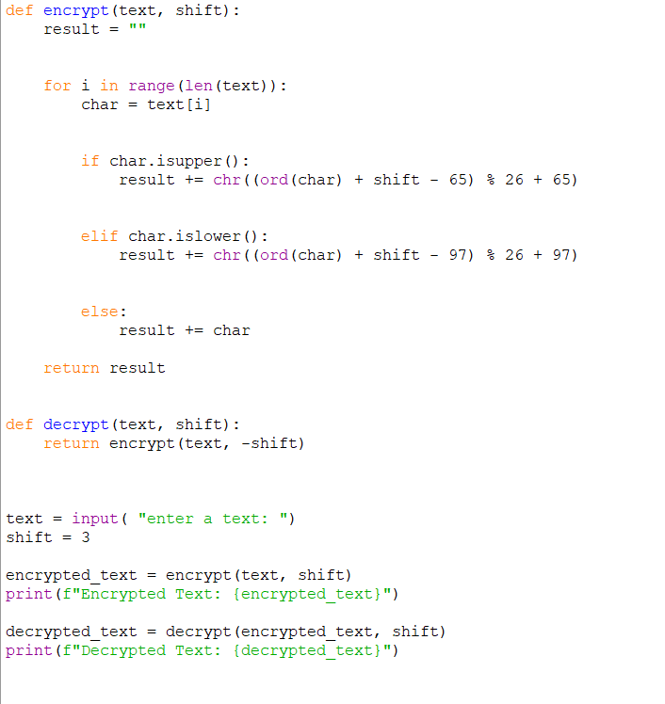

**OUTPUT:**

